THE SUTTONS
Neighbourhood Policing Team

YOUR LOCAL TEAM
 |  | 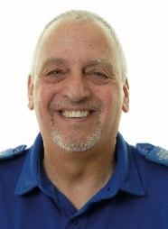
PC Paul Freeman |  | PCSO Dave Walker

FORTHCOMING ENGAGEMENTS
Thursday 6th April 1500-1600 Long Sutton Library
Friday 14th April 1400-1500 Curlew Centre
Friday 21st April 1000-1100 Market house long Sutton

Further engagements will be posted on social media.

LOCAL PRIORITY
It has been decided that for the next three months we will increase our patrols in the parks in our area due to the better weather and lighter nights which can encourage more people to congregate.
Our Priority for the next quarter is Youth Related ASB.
Our contact details are on the right. If you wish you can contact Crime Stoppers anonymously on 0800 555 111 or online at crimestoppers-uk.org
As always thank you for your help

WHAT’S BEEN HAPPENING
Hello once again from your policing team and Spring is finally here,
Thank you to everybody who have let us know about drugs within our community.
As always drug use and supply which was our last priority is always near the top of our list, please continue to let us know of any information that could be of use.
As you can see the dates of the forthcoming engagements are to the left and if you wish to pop in for a chat please do.
It appears that members of our community are happy to post on social media regarding ongoing ASB and crimes and not inform us via 101. Please call 101 to report issues to us. If we don’t know we can’t help.
Please contact us and talk to us as only with your help can we make our community a better place to live and work.
Thank you for your positive feedback so far.
PCSO Dave Walker
07973846299

Pc Paul Freeman
07973848231
holbeachandsuttons@lincs.police.uk

